**CV Maker**

It is an application that simplifies the task of creating a resume for individuals. Individuals just have to fill up a form that specifies questions from all required fields such as personal questions, educational, qualities, interest, skills and so on.

* **Login Page**

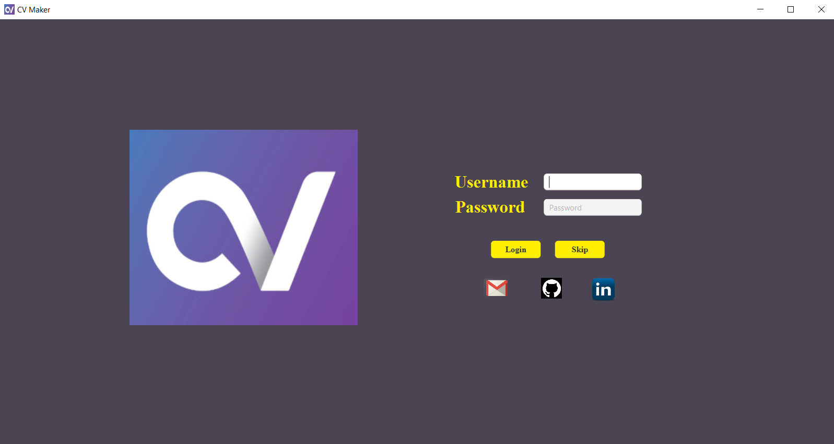

* **Home Screen**

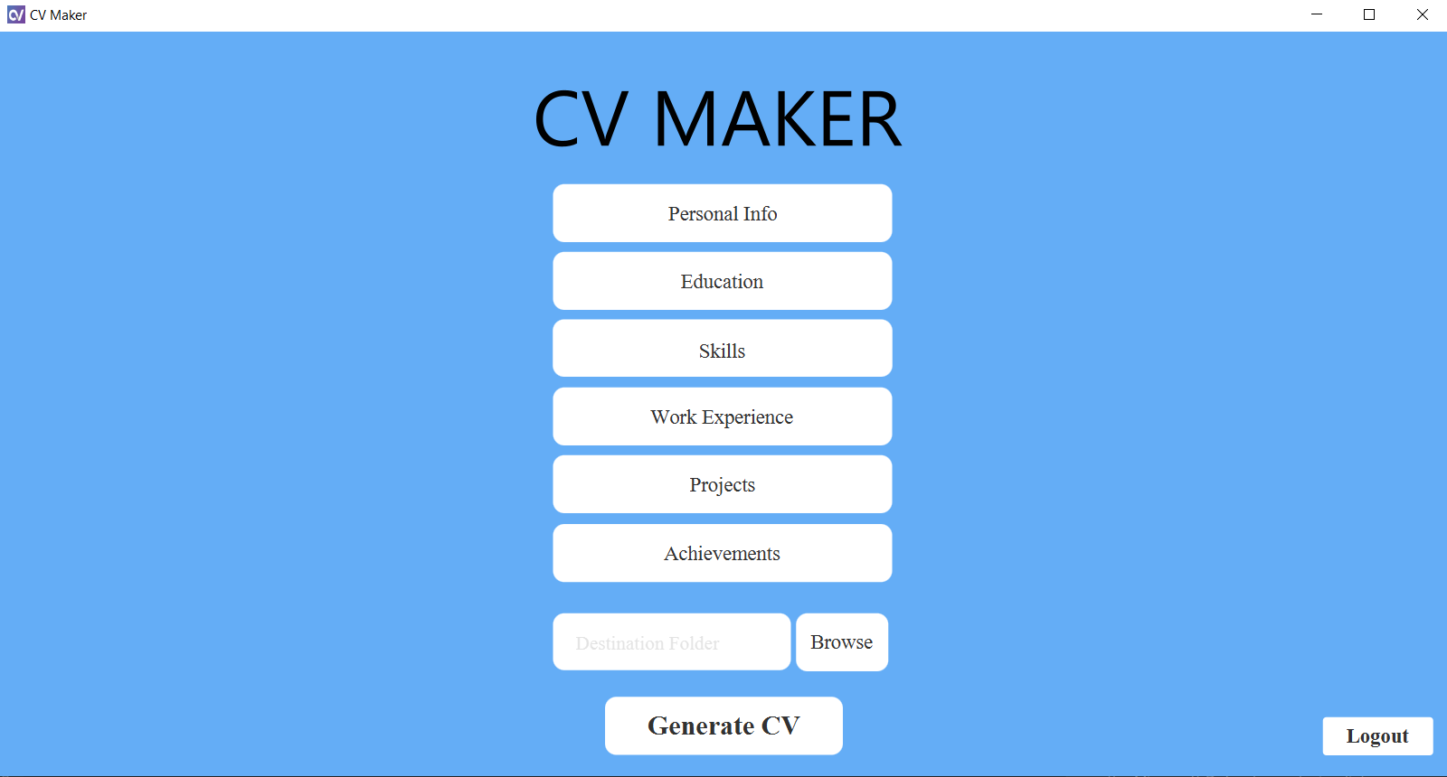

* **Personal Information**

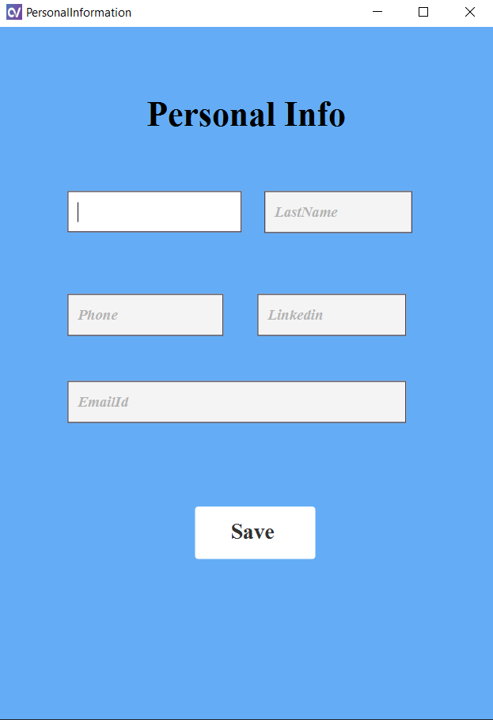

* **Skills**

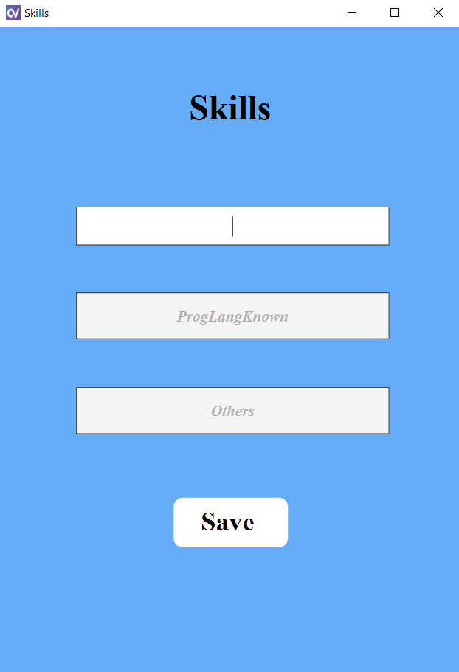

* **Work Experience**

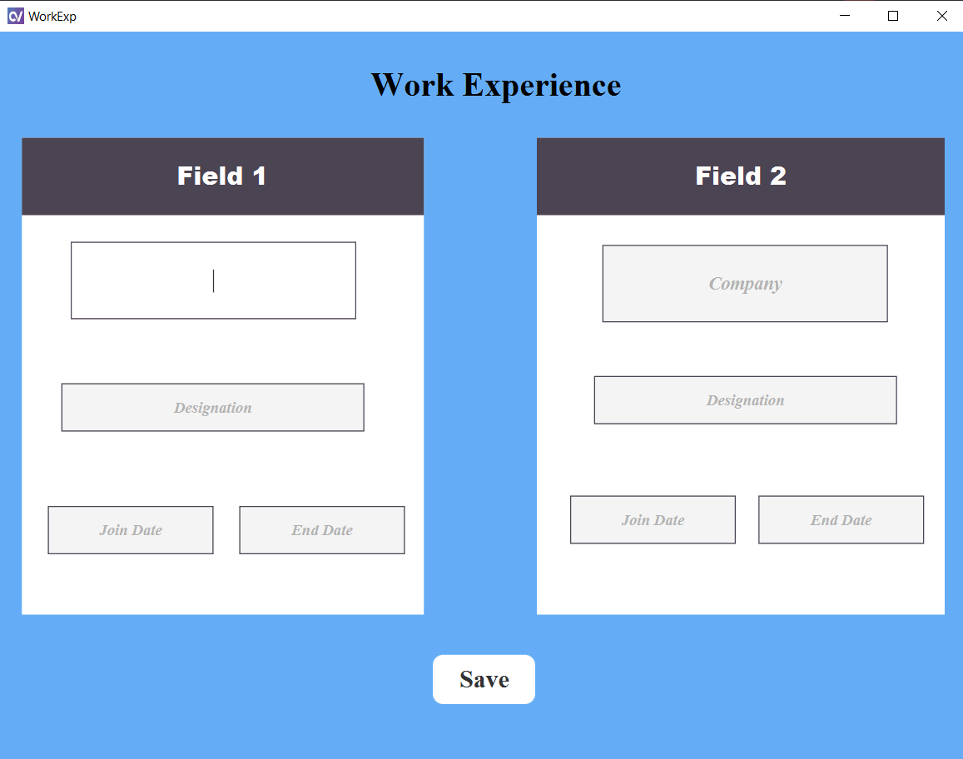

* **Projects**

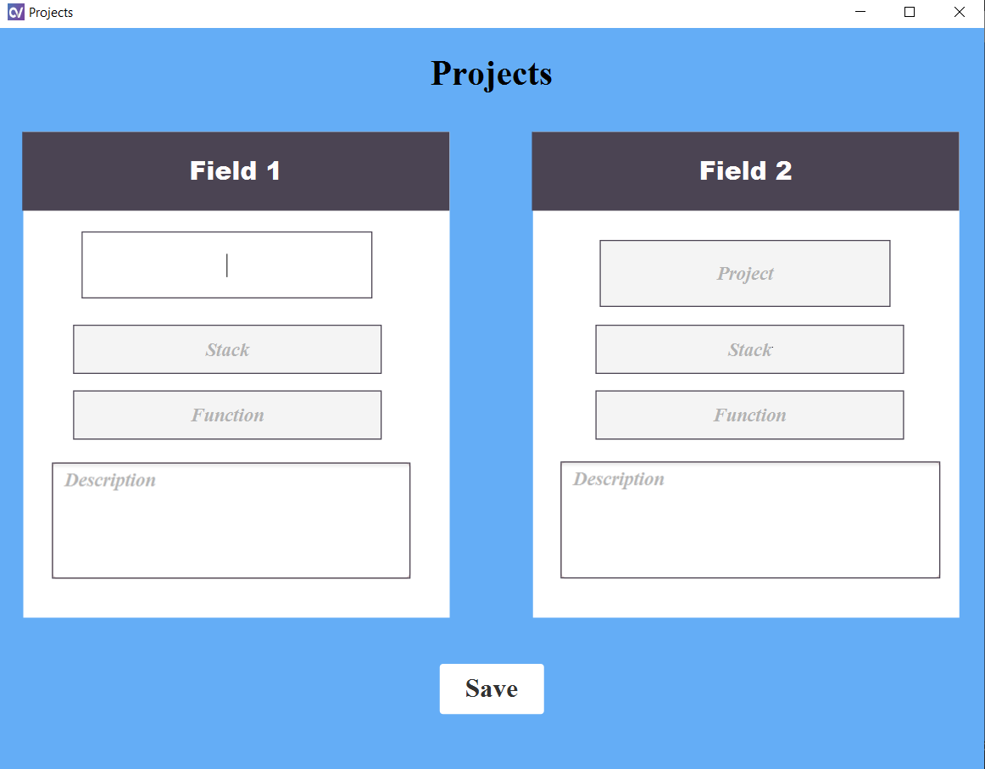

* **Education**

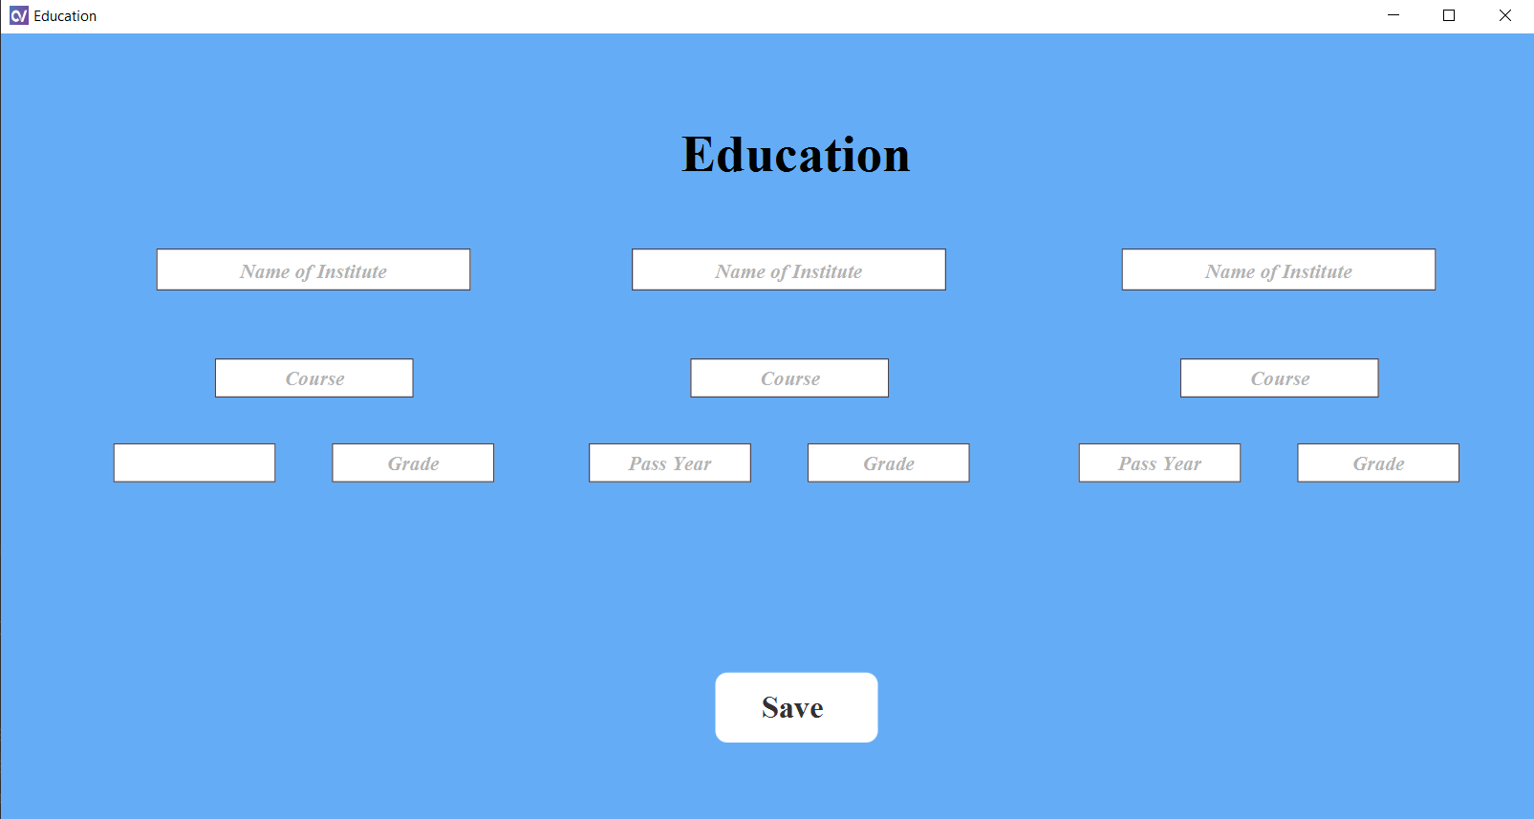

* **Achievements**

